29. Bar Chart with Different Colors for Each Bar

import matplotlib.pyplot as plt
languages = ['Python', 'Java', 'C++', 'JavaScript', 'C']
popularity = [90, 80, 70, 85, 65]
colors = ['red', 'blue', 'green', 'orange', 'purple']
plt.bar(languages, popularity, color=colors)
plt.xlabel("Programming Languages")
plt.ylabel("Popularity")
plt.title("Popularity of Programming Languages")
plt.show()

OUTPUT:
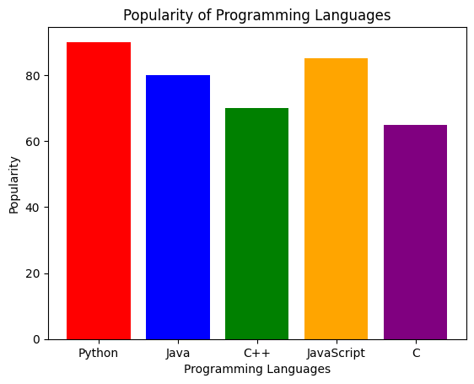

30. Bar Plot of Scores by Group and Gender

import matplotlib.pyplot as plt
import numpy as np
groups = ['Group A', 'Group B', 'Group C', 'Group D']
men = [75, 85, 70, 90]
women = [80, 78, 85, 88]
x = np.arange(len(groups))
width = 0.35
plt.bar(x - width/2, men, width, label='Men')
plt.bar(x + width/2, women, width, label='Women')
plt.xlabel("Groups")
plt.ylabel("Scores")
plt.title("Scores by Group and Gender")
plt.xticks(x, groups)
plt.legend()
plt.show()

OUTPUT:
